Stage 2 Physics
Test 1 – Vectors and Rectilinear Motion

Name:

___/50

Instructions to students:
Complete all questions on this paper
Show all working out to gain full marks.
Answer all numerical questions to 3 significant figures.
Allowed Equipment:
Physics Stage 2 Formulae and Data sheet 2014 – supplied
Authorised scientific calculator – students to supply

- Jenny and her best friend, Sara, live on opposite sides of a football oval (refer to diagram 1 below). Usually Jenny is able to walk across the oval to Sara’s house. However, on Saturdays there is always football being played and so she must walk around the oval (a distance of 200 m). On Saturdays it takes Jenny 2 minutes to get to her friend’s house.
[3,2 = 5 marks]

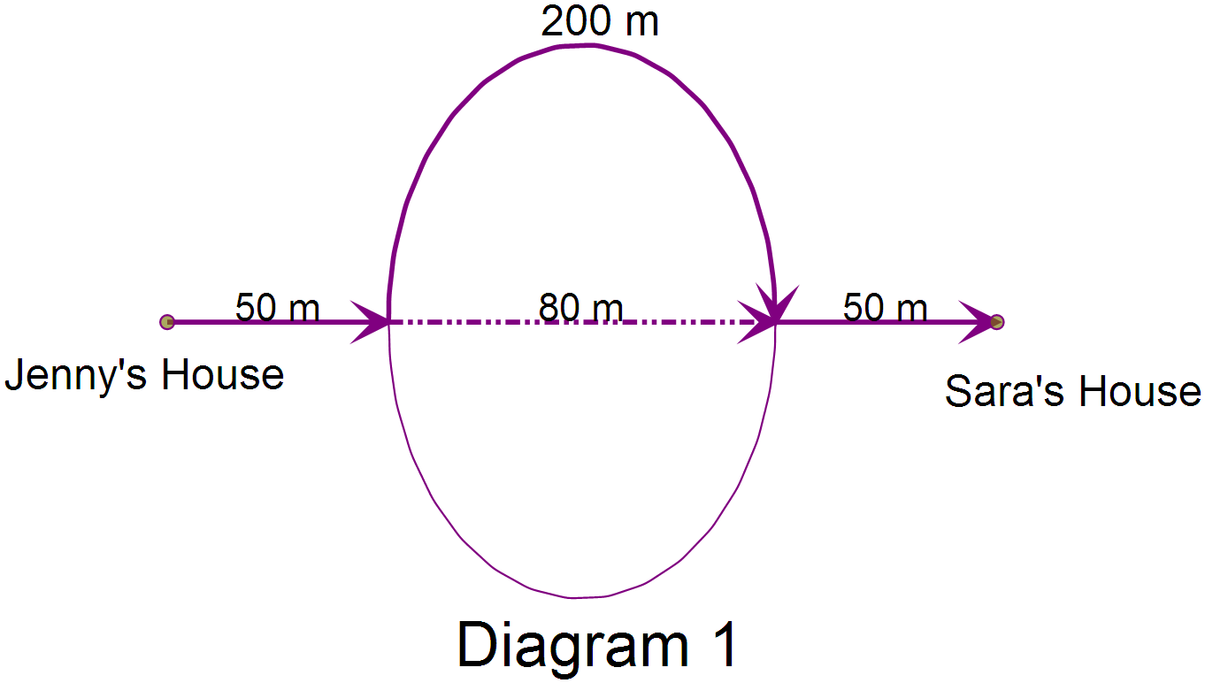

  - What is Jenny’s average speed when she walks to Sara’s house on Saturdays (in ms⁻¹)?

  - What is Jenny’s average velocity on Saturdays?

- Listed below are physical quantities in scalar and vector rows. Circle the incorrect quantities from the two rows below
[3 marks]

Scalar | Mass | Volume | Displacement | Distance | Speed
Vector | Velocity | Weight | Area | Acceleration | Energy

- Convert the following into scientific notation and express your answer correct to 3 significant figures. [1,1 = 2 marks]
  - 50 565 784
  - 0∙00057345

- A young boy is flying his model aeroplane between two points on the ground. The plane takes off from Point ‘A’ and lands at Point ‘B’. The two points are 50 m apart. The model aeroplane has a maximum speed through the air of 6∙94 ms⁻¹.
[2,1,2 = 5 marks]

  - How long would the model aeroplane to fly 50 m at its maximum speed?

  - Explain, using principles of motions, why it is unlikely that the plane will ever achieve the time calculated above when flying between the two points. Assume the plane starts at rest and stops at Point ‘B’.

  - Explain (using a vector diagram) the effect of a 3 ms⁻¹ headwind on the maximum velocity of the model aeroplane.

- Transfer the information shown on the displacement-time graph below to a velocity-time graph. [4 marks]

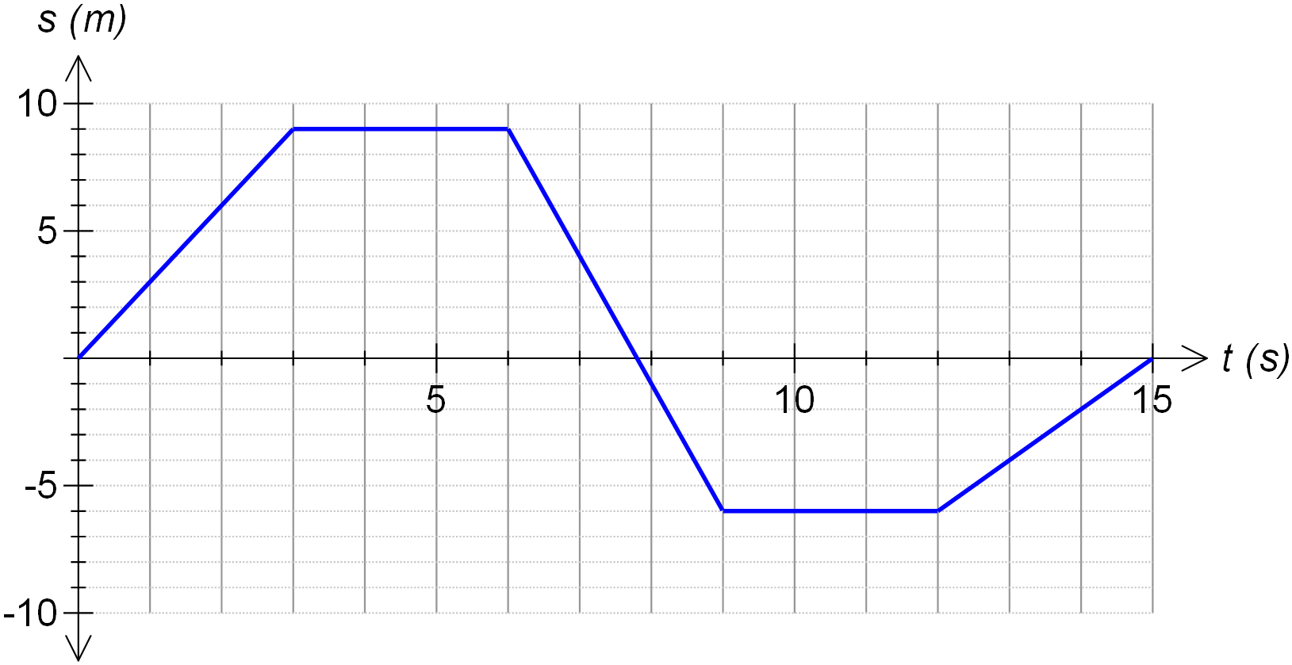

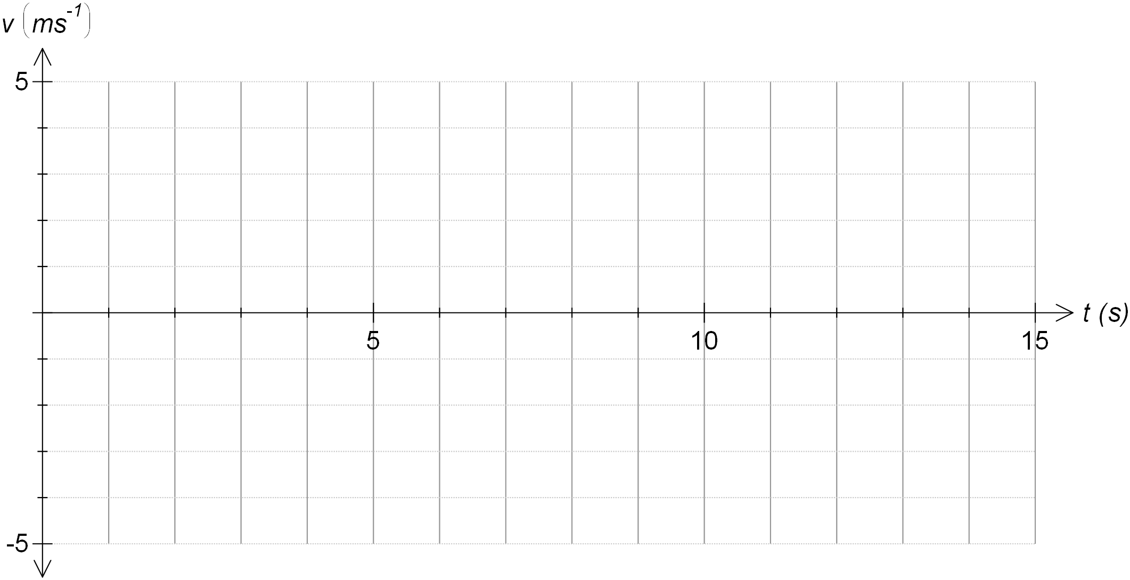

- The following questions relate to the velocity-time graph below: [1,1,3,2, = 6 marks]

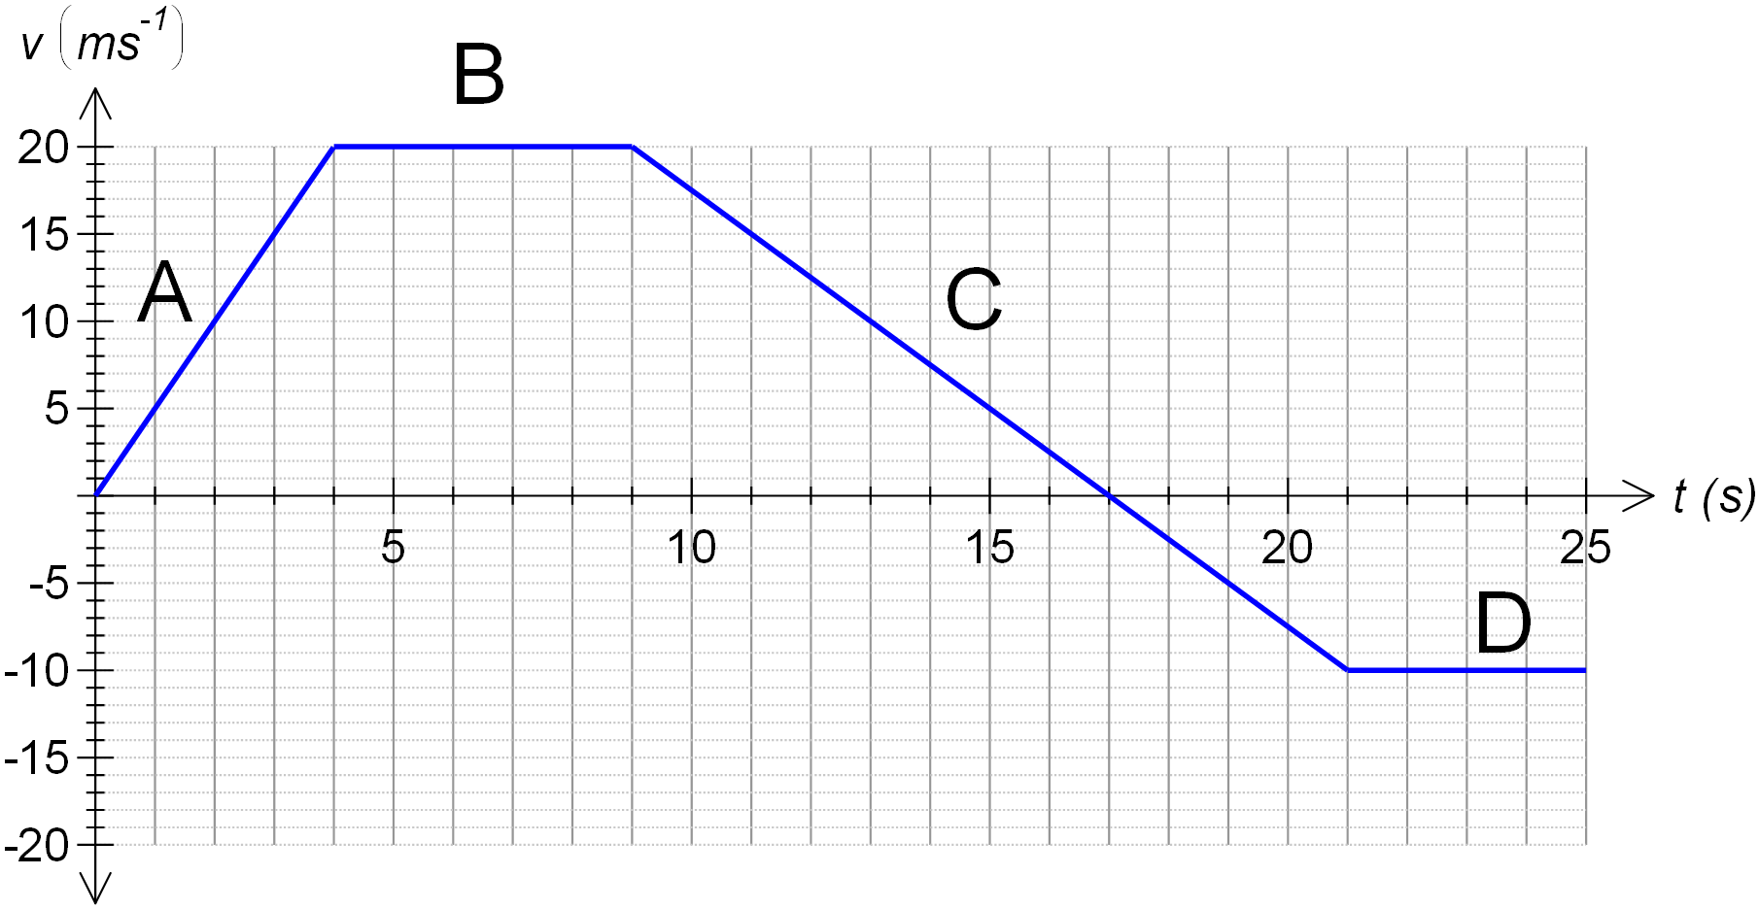

  - In which section(s) did the object have a constant velocity?

  - In which section did the object have the greatest acceleration?

  - What is the final displacement of the object?

  - What is the total distance travelled by the object?

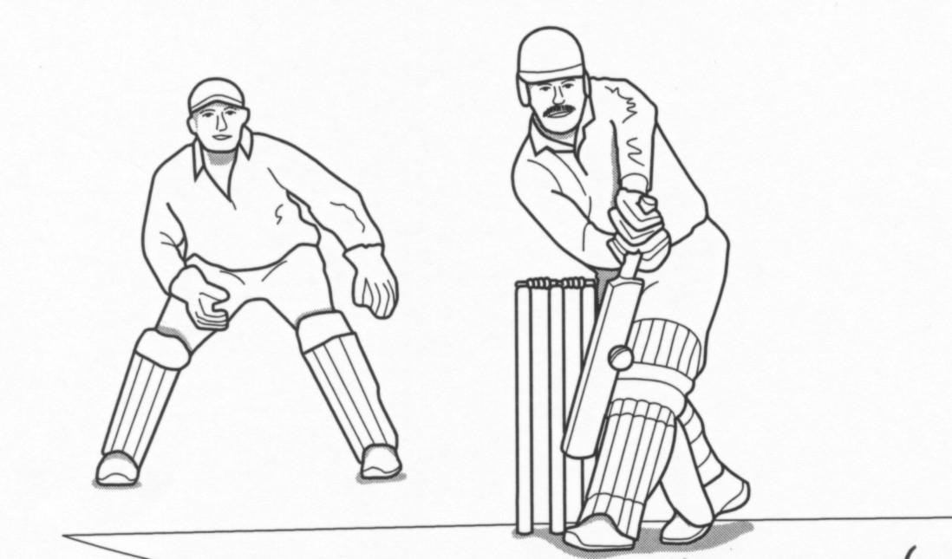
- In an international cricket match a bowler bowls a ball in an easterly direction at 38∙9 ms⁻¹. The batsman drives the ball back past the bowler with a velocity of 46∙5 ms⁻¹. The bat is in contact with the ball for 0∙020 s. [1,2,2 = 5 marks]

  - Calculate the change in speed of the ball.

  - Calculate the change in velocity of the ball.

  - Calculate the acceleration of the ball during its contact with the bat.

- The steam catapult on the air craft carrier USS Ronald Regan is able to ‘launch’ aircraft with an acceleration of 3∙78 × 10¹ ms⁻² for 1.95s. [2,2 = 4 marks]
  - What is the final velocity of the aircraft at the end of the launch?

  - What is the displacement of the aircraft during this time period?

- After passing through the freeway interchange in West Perth the speed limit increases from 80 kmh⁻¹ to 100 kmh⁻¹. With some effort, my car is able to achieve this change in velocity over a distance of 100 m. [2,3,2 = 7 marks]

  - Convert both the above speeds to ms⁻¹

  - What is the acceleration of my car?

  - How long is the car accelerating for?

- Gerald has a potato gun which launches potatoes at 35∙0 m s⁻¹. If he fires the potato gun straight up from the top of a 10-metre tower and the potato just misses the tower on the way down and lands on the ground: [3,2,4 = 9 marks]

- How high will the potato reach (measured from the ground)?

- How long will it take to reach this maximum height?

- How long in total will it be in the air before it lands on the ground?

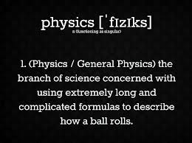
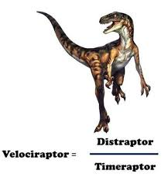

END OF TEST

